Liz Van Deslunt

May 6, 2014

Javascript Final Project Proposal

# Project Proposal

I would like to develop a website for a fictional sushi restaurant, Volcano Sushi. The website will include an online order form, an interactive menu, and a specials page.

## Homepage

The homepage will contain a description of the restaurant and a slideshow of restaurant photos

## Order Form

The order form will use the standard jQuery validator that has been used in our previous class projects, and will hide/display fields based on the user’s selections. For example, if the user selects “Delivery” order, they will be shown fields to enter an address, but if they select “Carryout,” those fields will not appear. The order form will also include an “Add Item” button to allow the user to add as many items to their order as they wish, without restricting them to a predetermined number of items or cluttering the form with dozens of “Item” combo boxes. Below is a simple outline of the information that the form will contain. After entering their information, a summary/confirmation screen will display their order. See flowchart 1 for a detailed explanation of the logic.

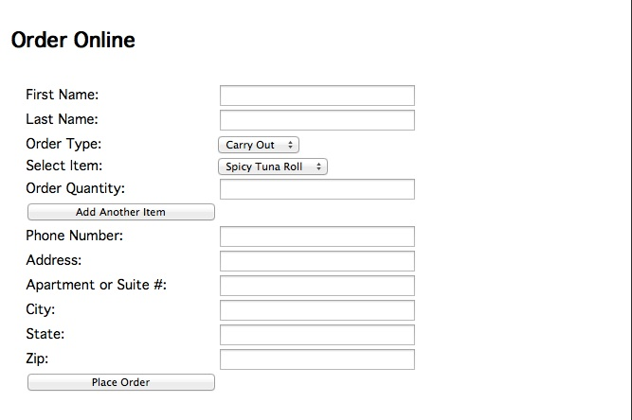

## Interactive Menu

The menu will be tab-based, with a tab for different menus (e.g. Sushi, Sashimi, Specialty). Within each tab, the menu items will be listed by name. When the name is clicked, the item will expand (using jQuery slide() method) to show a description and photo. Clicking again will hide this information. I would also like to add a very simple search feature. Customers will be able to select ingredients they would like in their sushi roll, and the page will display all the menu items that contain one or more of these ingredients.

\\psf\Home\Documents\School\WCTC\Javascript\Final Project sushi\Proposal\search.tiff

This simple search functionality can be accomplished with CSS classes (one per ingredient). Each menu item will be tagged with the ingredients it contains (e.g. “salmon”, “cucumber”, and “avocado”). When the user searches for ingredients, all menu items that do not contain at least one of those ingredients will be set to “hidden” (display: none). See flowchart 2 for a visual representation of the logic.

## Specials Page

The Specials page will contain a list of upcoming specials/discounts at the restaurant. If I have time, I would like to incude a calendar to make viewing the events easy. I would use either the CLNDR plugin1 or Kalendar plugin2 for jQuery.

## Extra Credit Proposals

* Slideshow on homepage
* Calendar plugin on Specials page

## References

1. CLNDR jQuery plugin: <http://kylestetz.github.io/CLNDR/>
2. Kalendar jQuery plugin: <http://www.ericwenn.se/kalendar/>

Flow Charts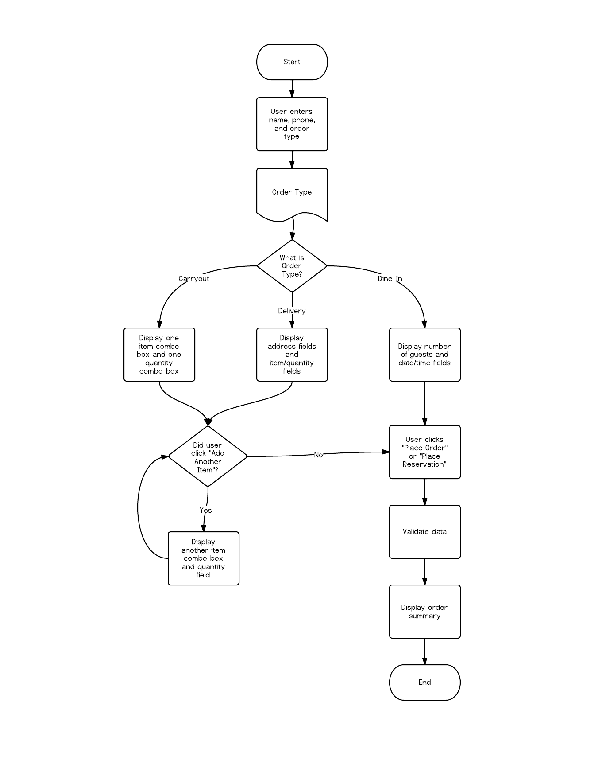

Flowchart : Responsive Order Form

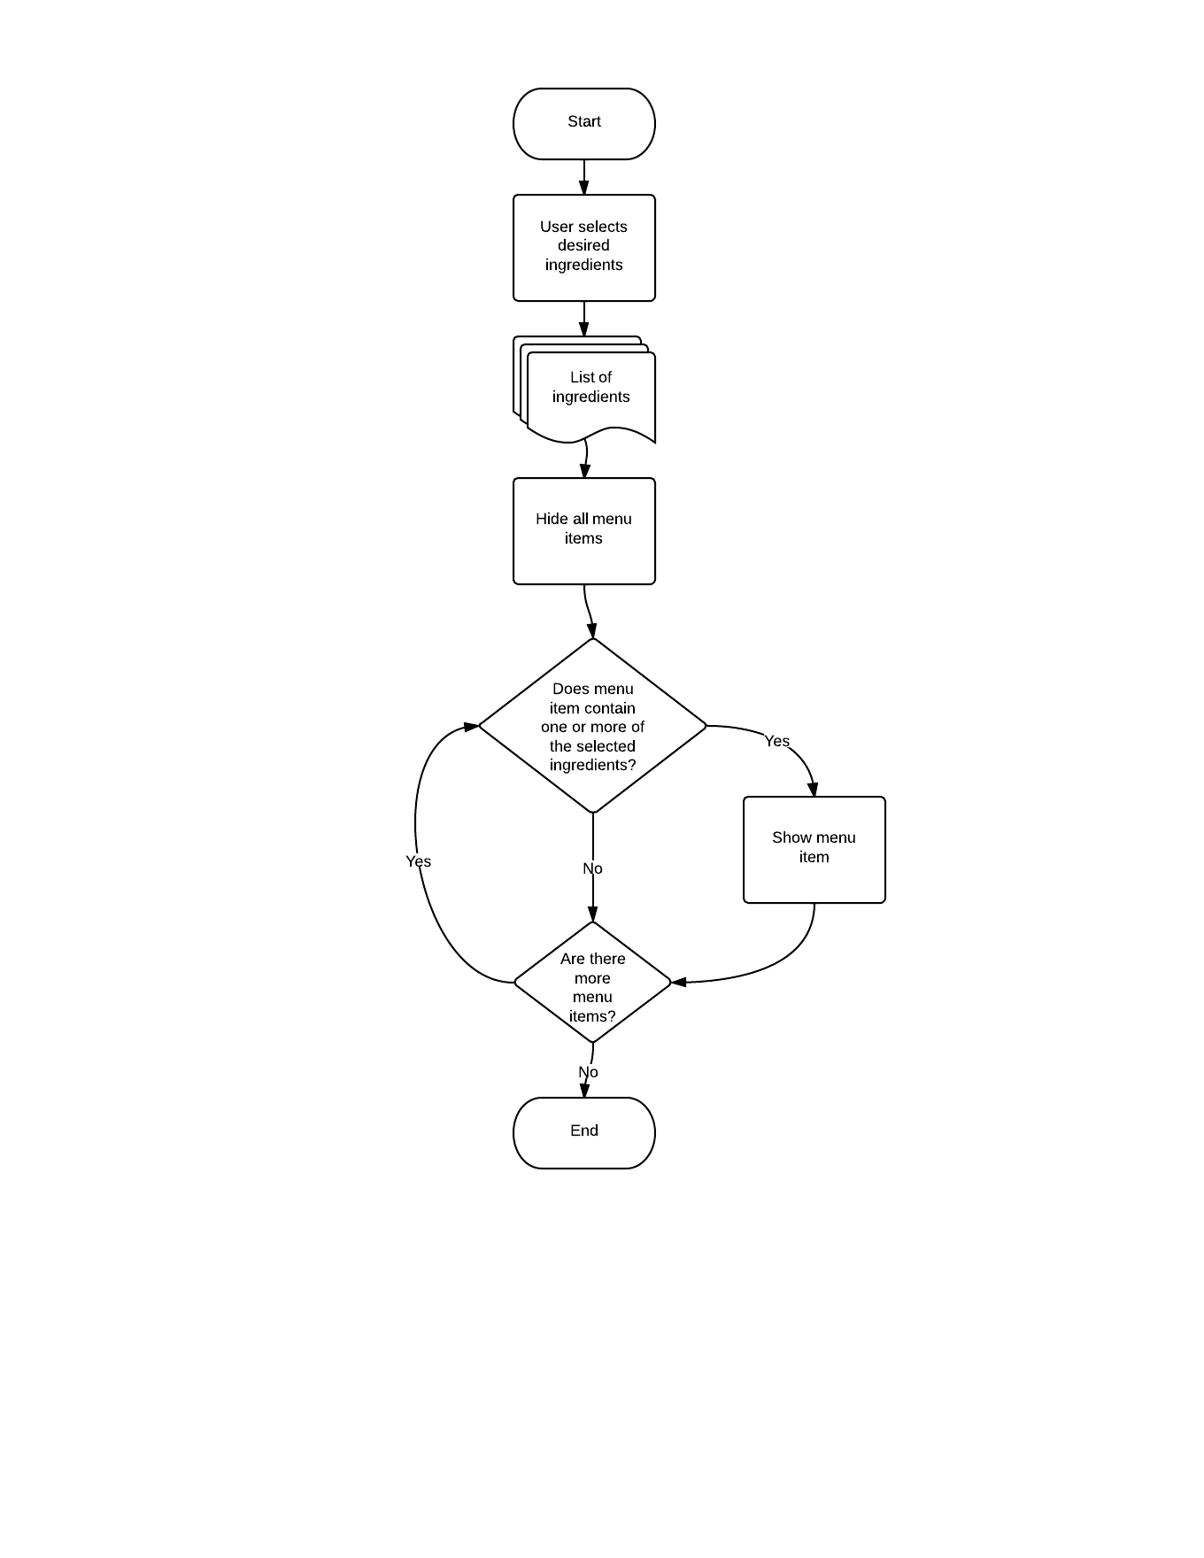

Flowchart : Searchable Menu